


Stage 1: Creating qualifications

Produced by: Gary Harlock

On behalf of: Perspective Limited
The Oracle Building
Blythe Valley Business Park
Shirley, Solihull
B90 8AD

30th October 2010

Log In
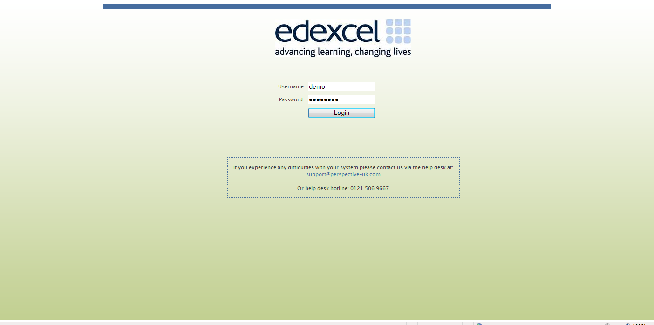

Home page
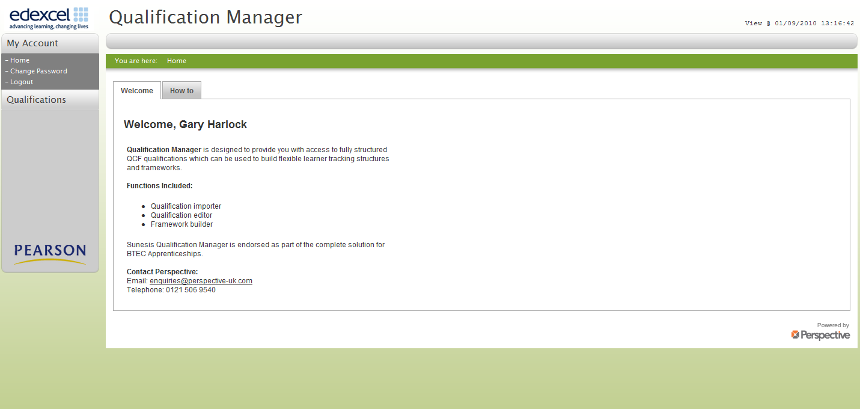

Add new Qualifications
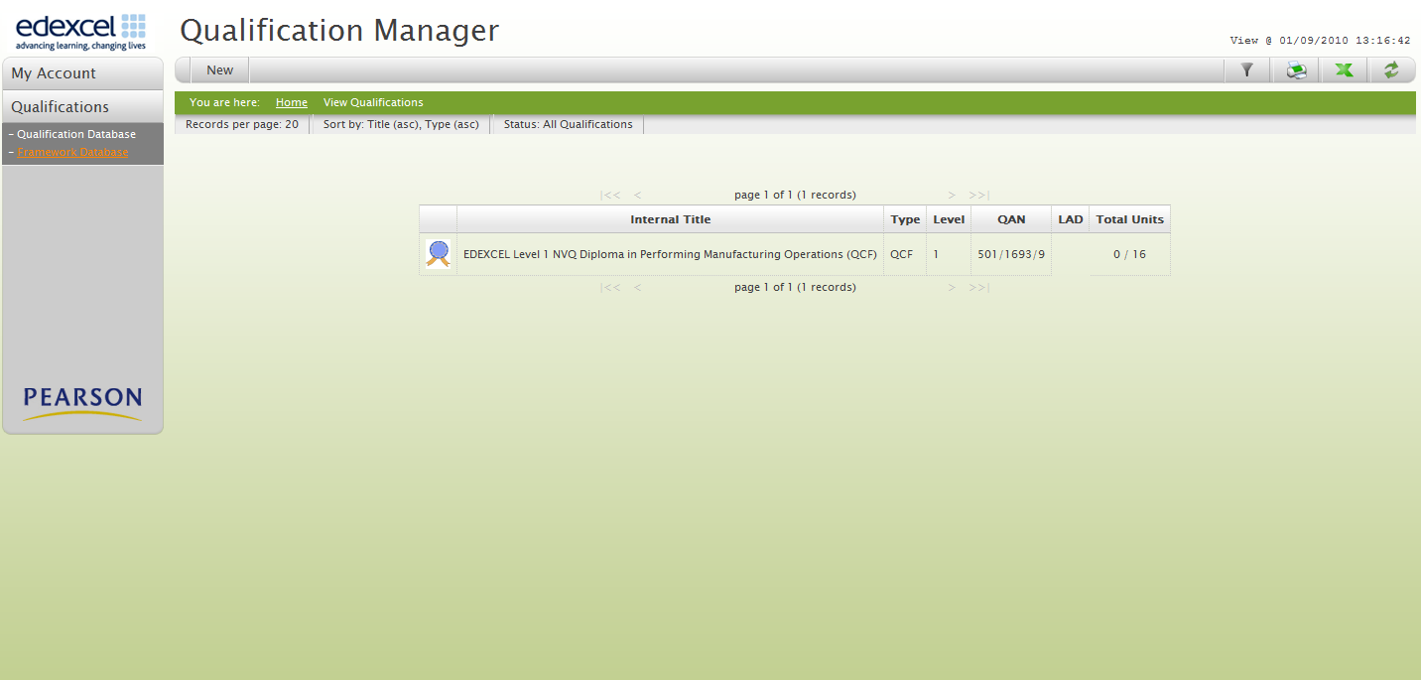
1: Click Qualification

2: Click New

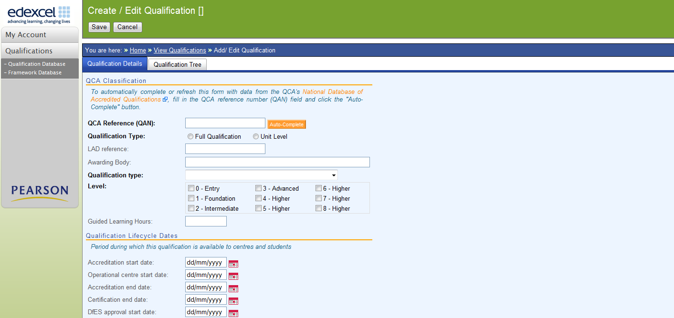
3: Click Qualification tab

4: Click RITS hyperlink

Link to The register of Regulated Qualifications (RITS)
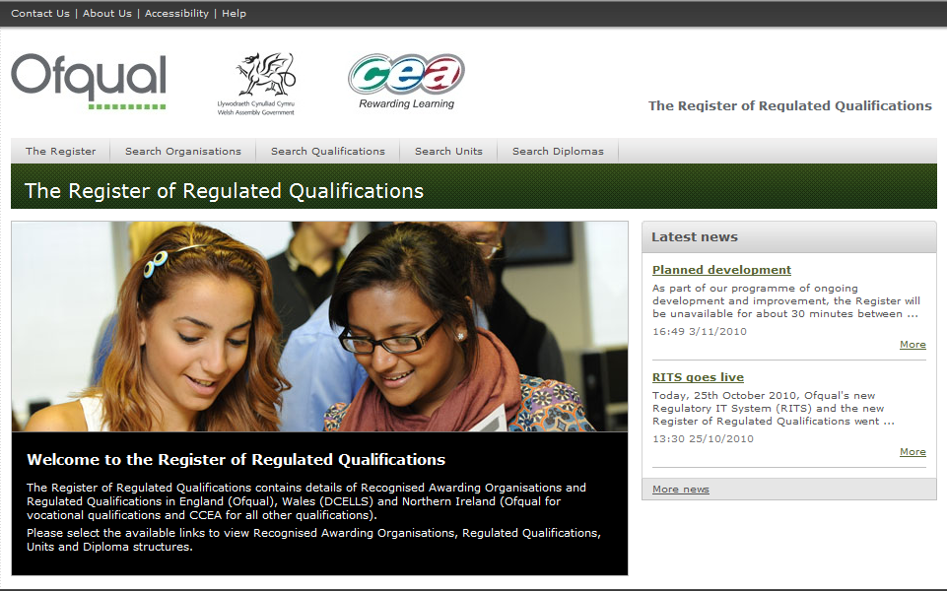
5: Click Search Qualification

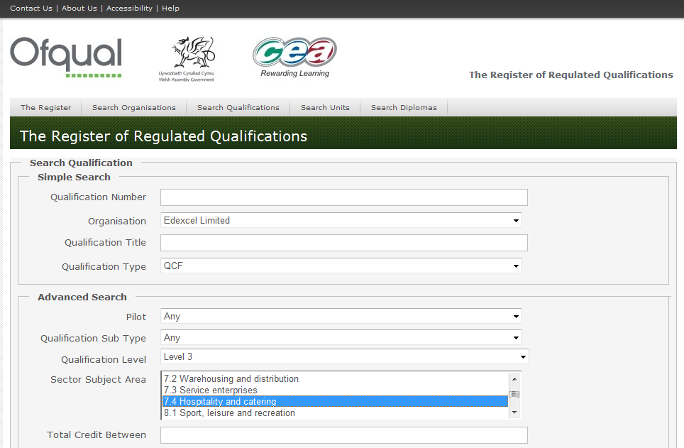
6: Add search criteria

7: Click Search

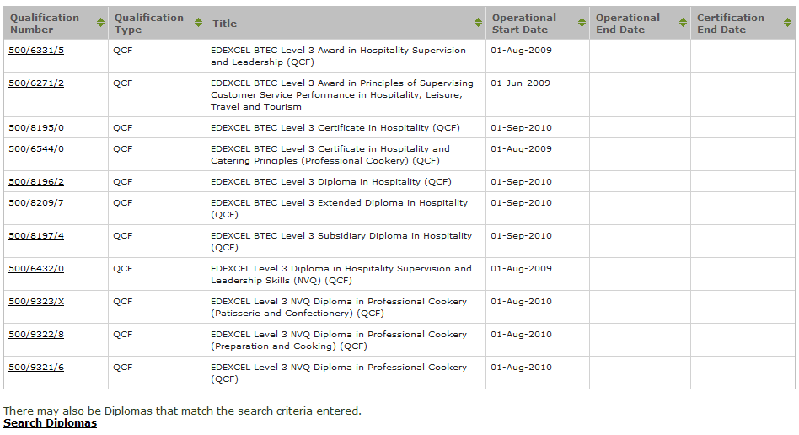
8: Identify Qualification, click to select

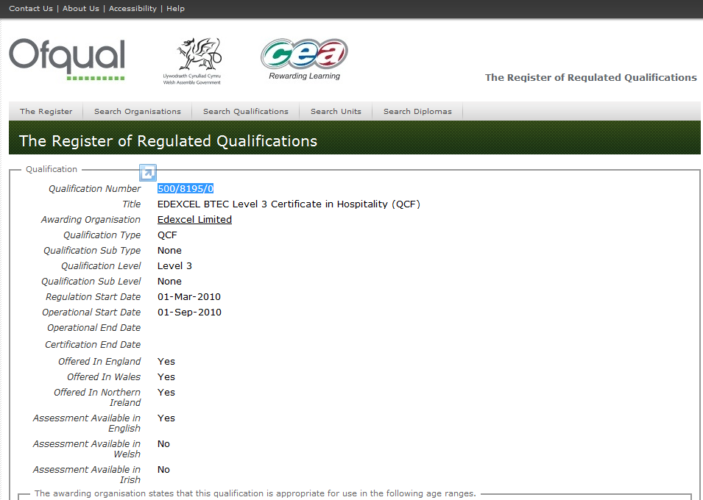
10: Copy Qualification Number

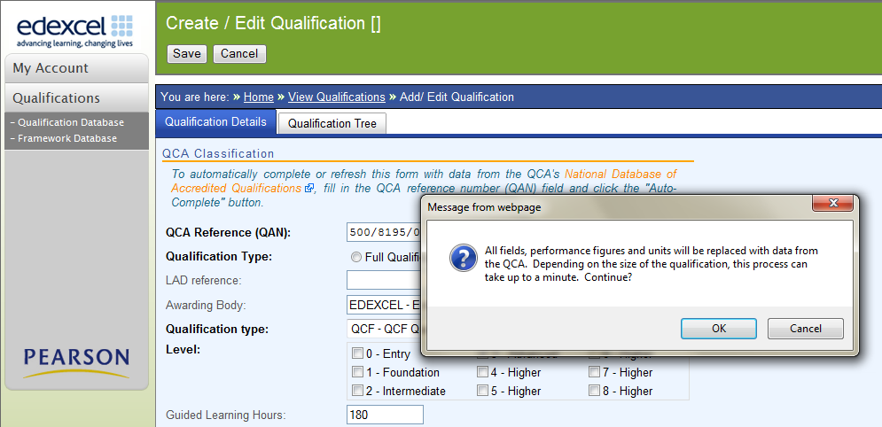
11: Paste number to box
12: Click Auto-complete and OK

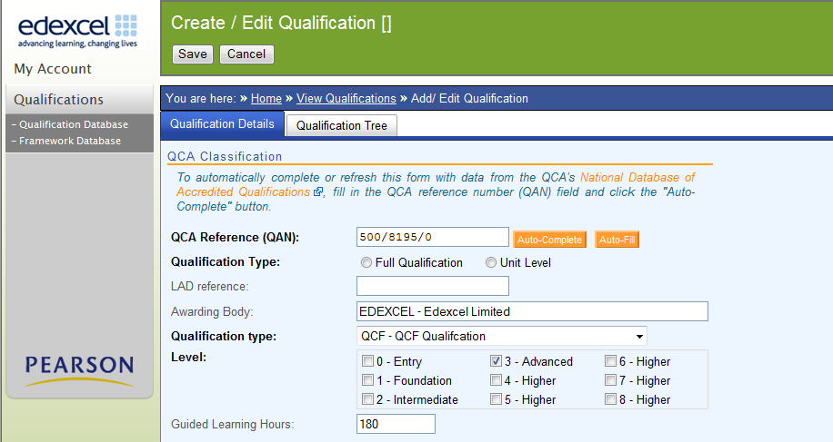
13: Save qualification

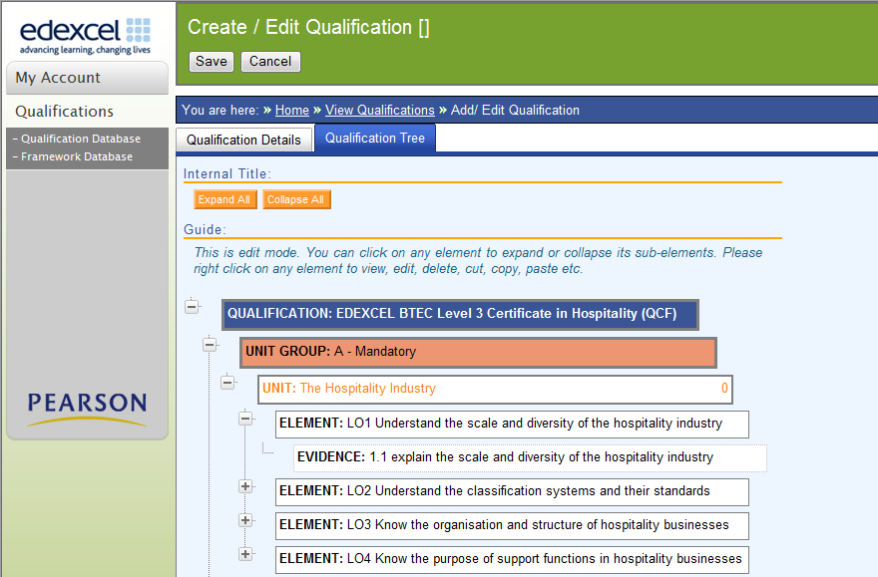
14: The qualification structure is populated with Units, Elements and Evidence

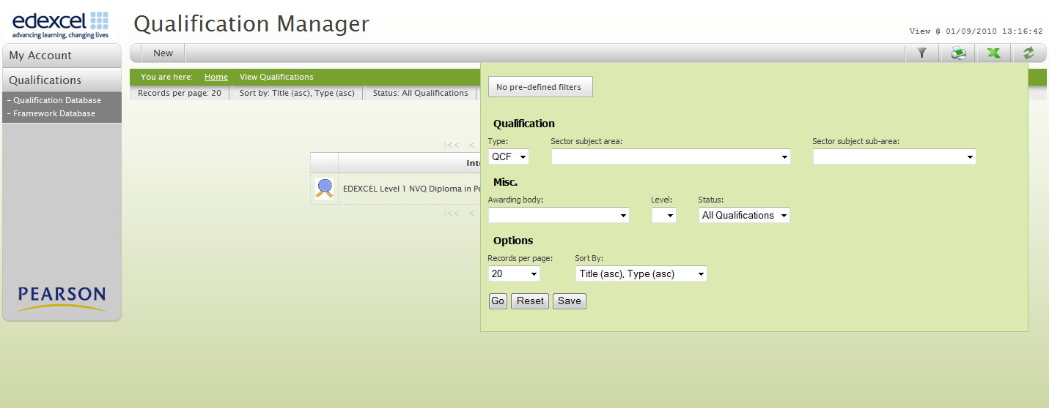
15: Apply filters for selecting qualification groups

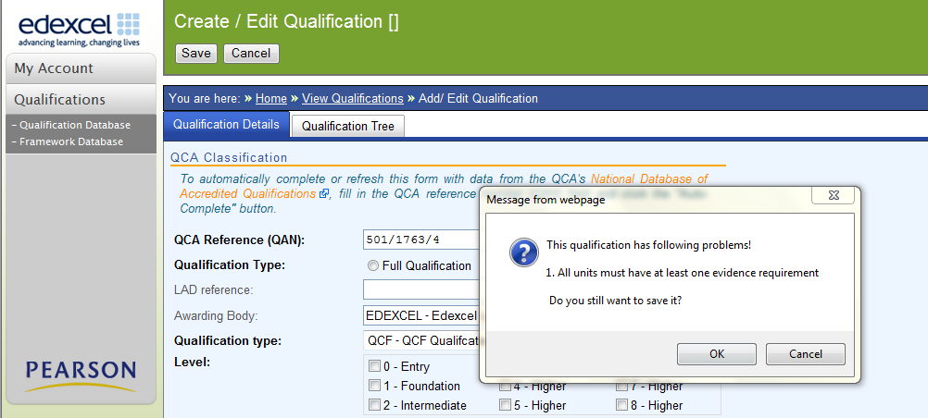
16: Contact support if this message appears during saves

How to recognise and report import issues
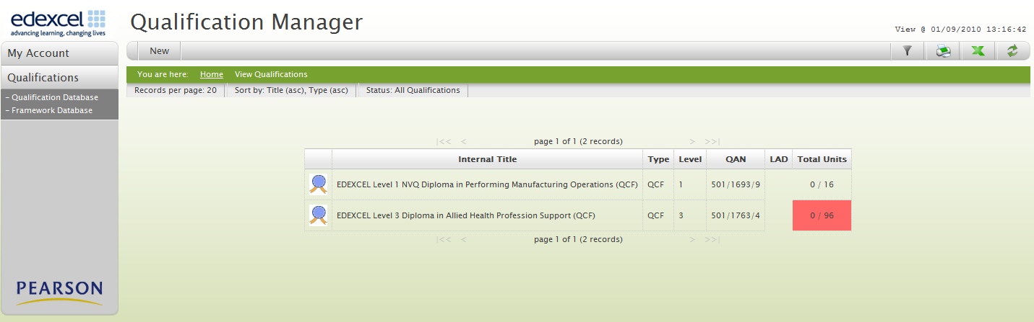
17: Contact support if this flag appears in the qualification list

Edit qualifications
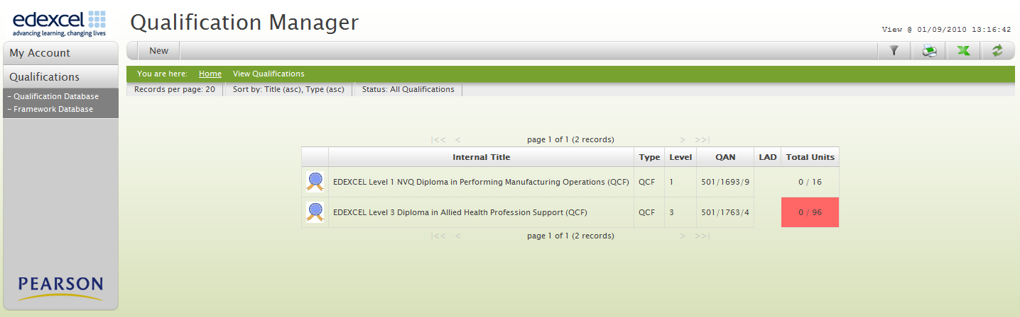
18: Select qualification to edit

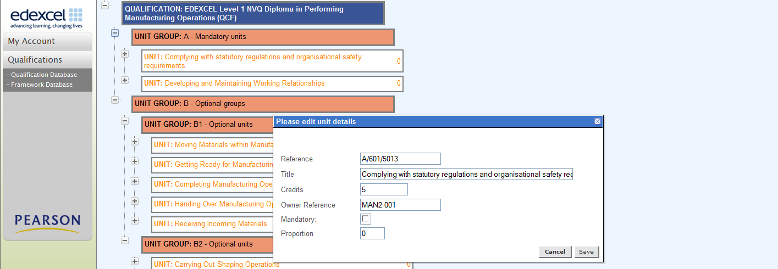
19: Tick mandatory or optional

20: Add proportion
21: Save

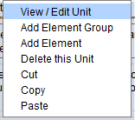
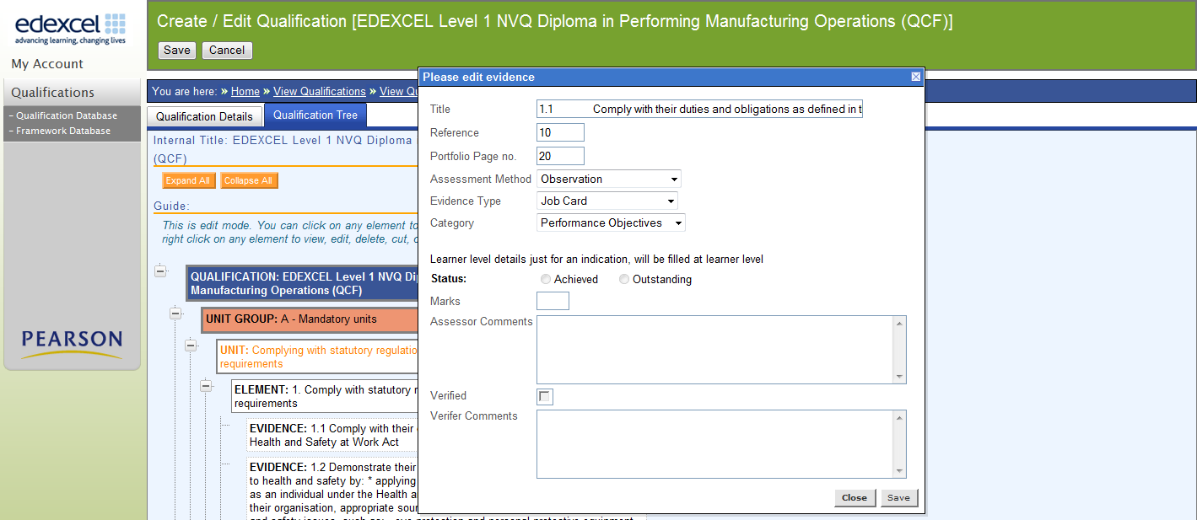
22: Right click evidence to add assessment criteria

Output of data
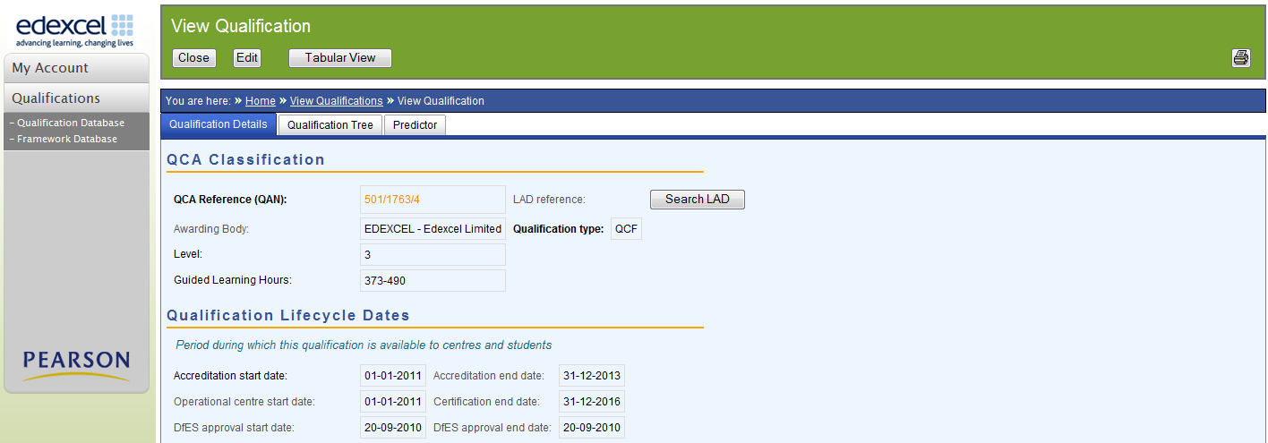
23: Click to view Tabular view

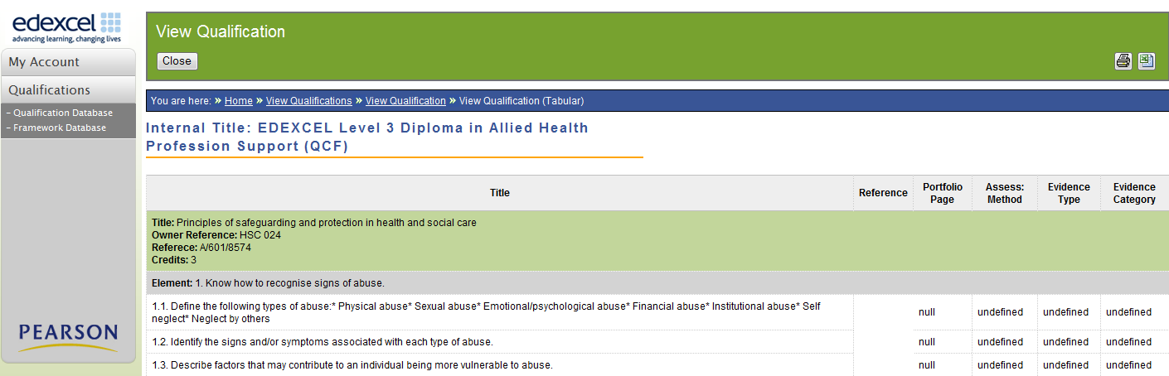
24: Confirm tabular view detail

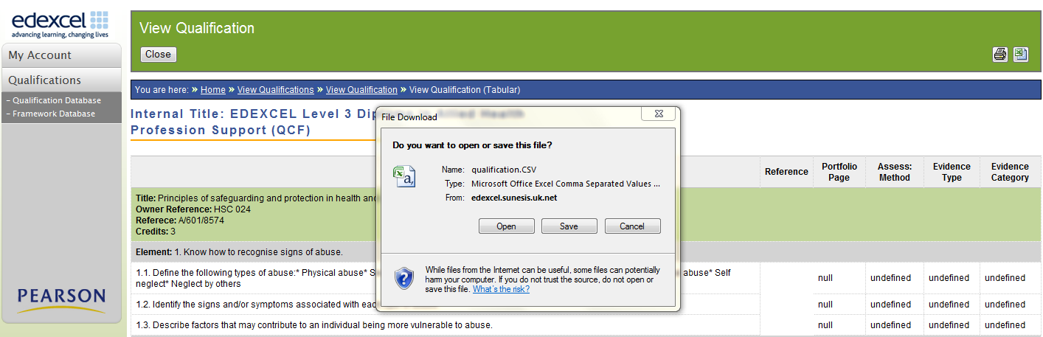
25: Click print to copy to excel spreadsheet

26: Click open or save to output spreadsheet

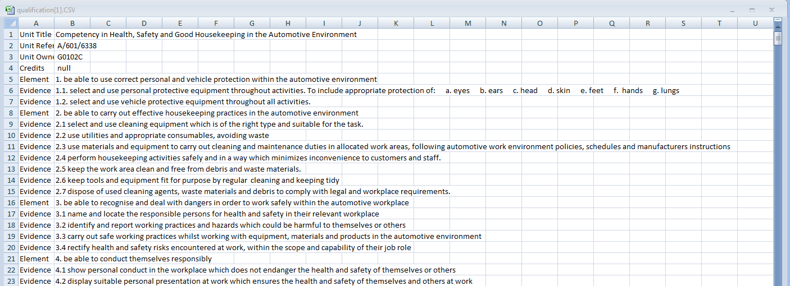
27: Export to csv file

Useful additions:
Learning Aim Database (LAD)
28: Link to qualification details in LAD.

Funding predictor enables you to calculate the amount of funding available for each qualification
29: Click to view Predictor

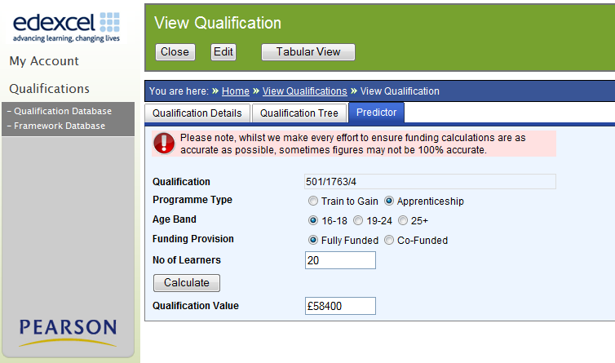

Framework database

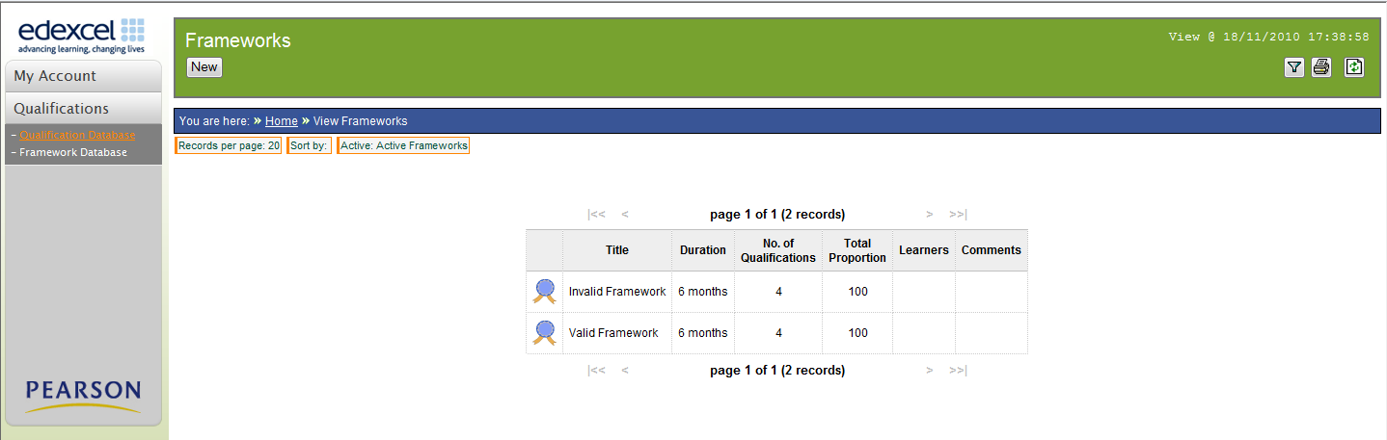
1: Select Framework Database

2: Select New

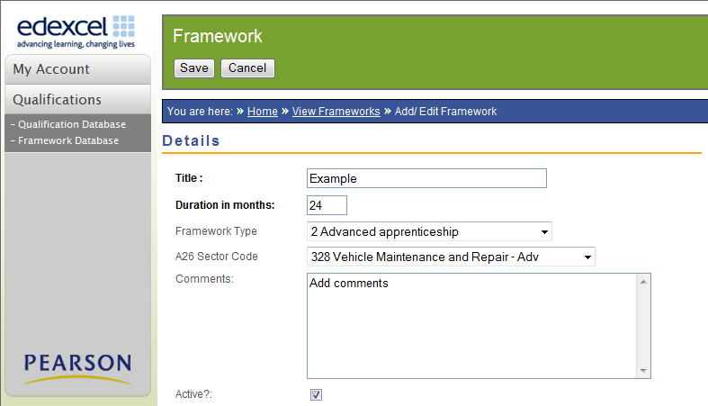
3: Add framework details and save

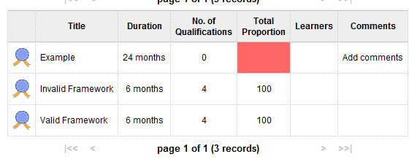
4: Newly created Framework

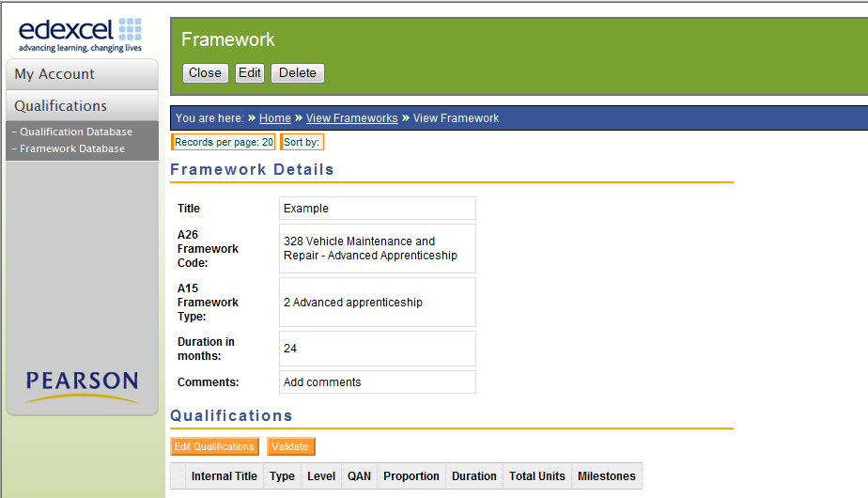
5: Select Edit Qualifications

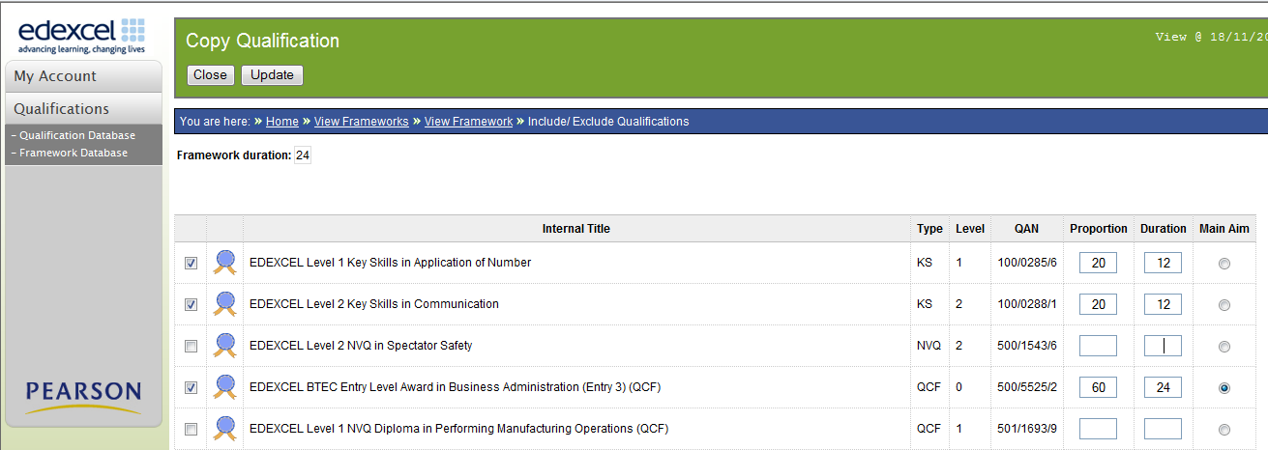
6: Select qualifications to add to framework database

7: Add contribution, duration and identify main aim

8: Click Update

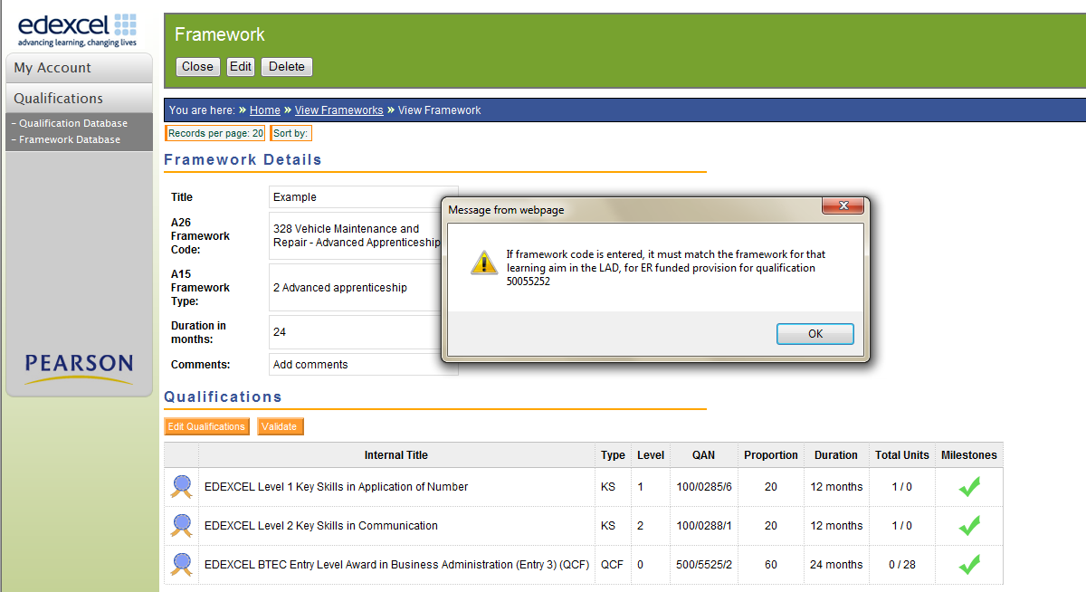
5: Select Validate

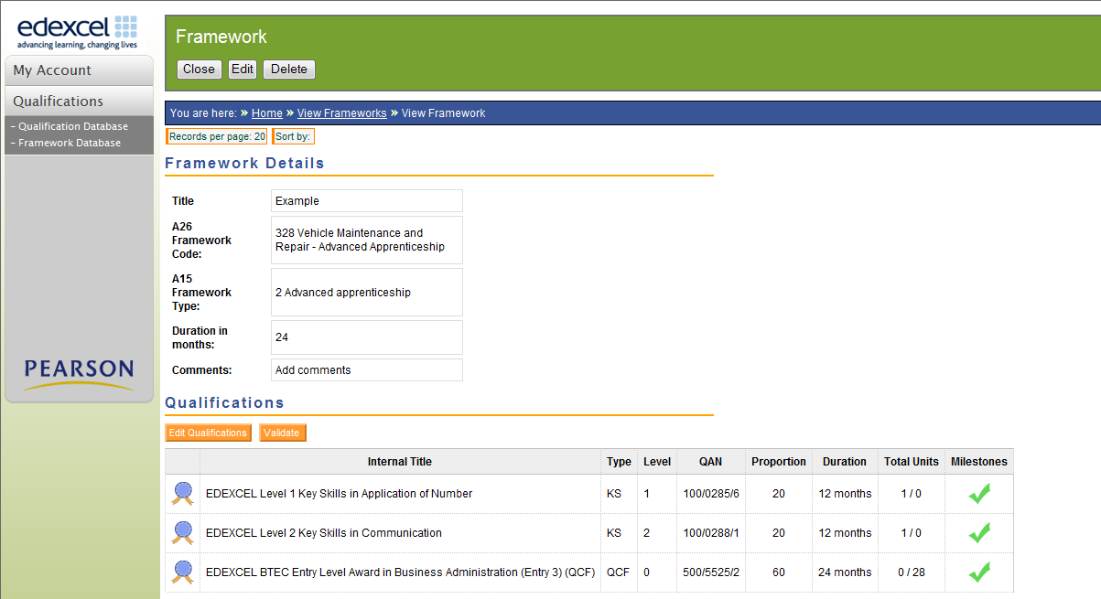
5: Select Edit Qualifications

Edit Qualifications
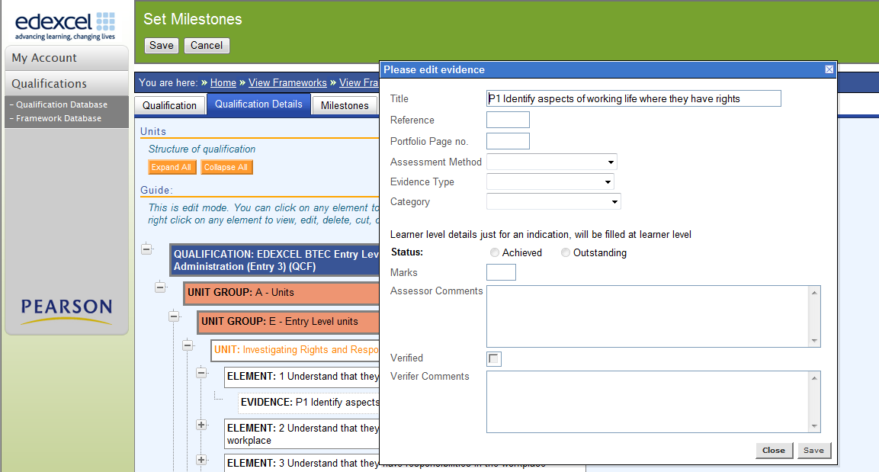

Set tracking milestones
